USING SQL TO DEMISTFY THE MODEL

Quiz 1: Group Players by Club and Count Total Players per Club

Quiz 2: Get the Average Overall (ovr) Rating per Club

Quiz 3: Find the Top 5 Clubs by Number of Players

Quiz 4: Get Total Male and Female Players per Club

Quiz 5: List Clubs and the Average Age of Their Players

Quiz 1: Group Players by Club and Count Total Players per Club

Essence:

We grouped players by club to see how many players each team has under contract. This reveals how big or small each squad is — helpful for planning transfers, balancing squad size, or flagging under/overstaffed clubs.

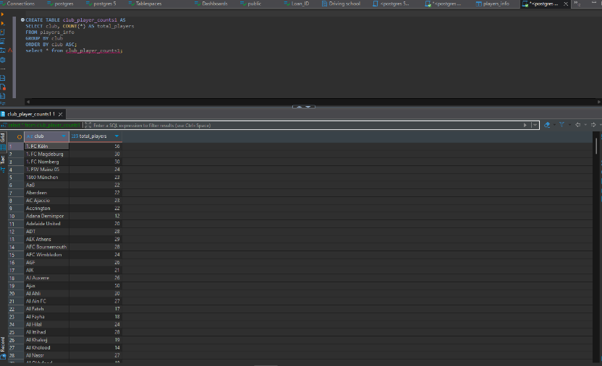

Quiz 2: Get the Average Overall (ovr) Rating per Club

**Essence**:  
We calculated the average player rating per club to measure the overall **quality** of each team’s squad.

Quiz 2: Get the Average Overall (ovr) Rating per Club

**Essence**:  
We calculated the average player rating per club to measure the overall **quality** of each team’s squad.

This shows which clubs have the strongest players on paper, and which might need improvement.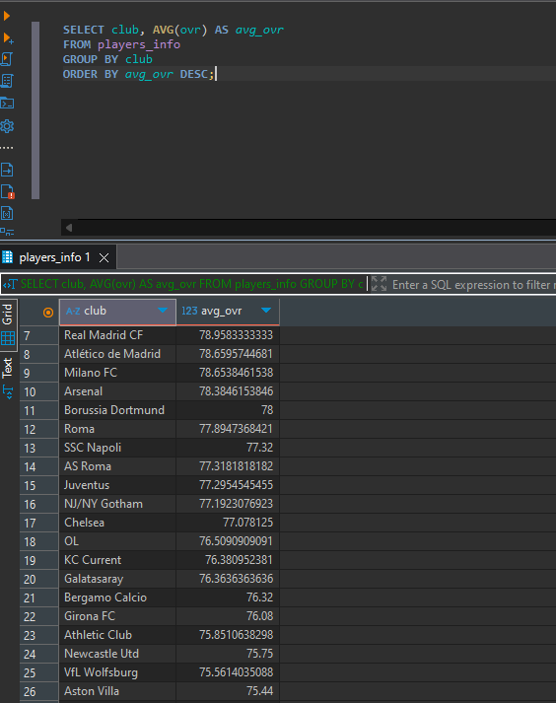

Quiz 3: Find the Top 5 Clubs by Number of Players

**Essence**:  
We identified the five clubs with the most players to quickly spot who has the largest squad. This helps in talent management and spotting clubs with potential player overload

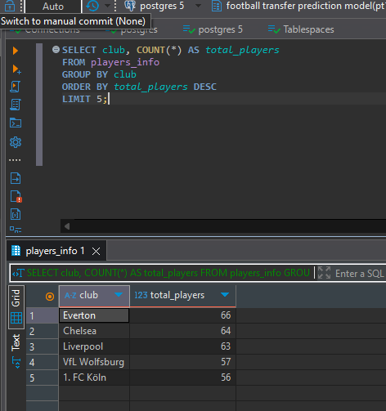

Quiz 4: Get Total Male and Female Players per Club

**Essence**:  
We compared the number of male and female players in each club. This helps evaluate **gender balance** across clubs and could inform decisions around inclusivity or league strategy.

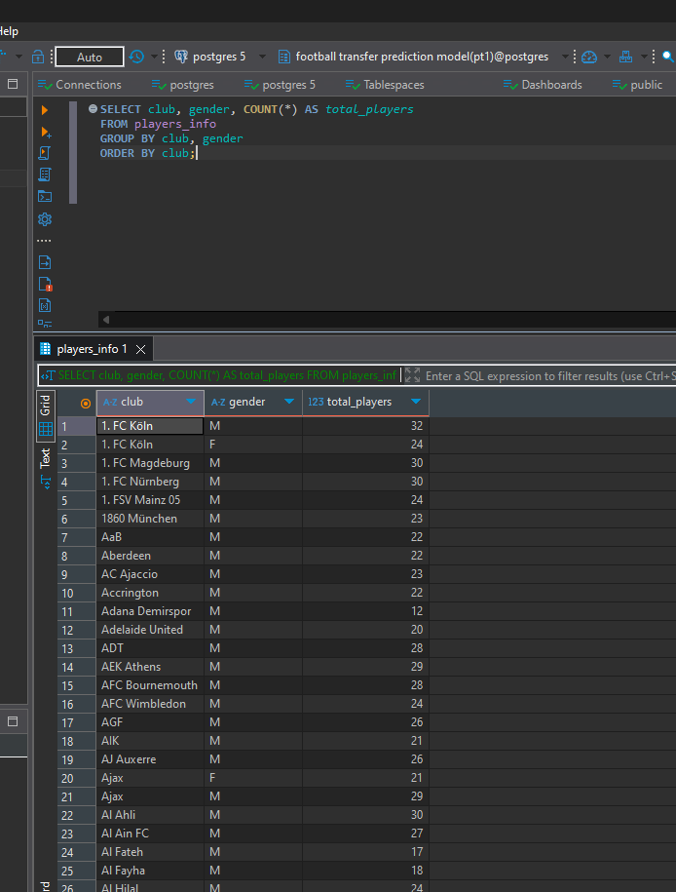

Quiz 5: **List clubs and the average age of their players**